AM000-Asia-China-Tang- **Mythical Creatures - Silver Plated - 52mm**

**Round Oriental Bronze Mirror - Chinese Mythical Creatures - Silver Plated - 52mm**

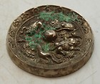

[Round Oriental Bronze Mirror - Chinese Mythical Creatures...](http://www.ebay.com/itm/330712870300?ssPageName=STRK:MEWNX:IT&_trksid=p3984.m1439.l2649) (330712870300)

Sale date: 04/28/12

Tracking number: --